**Chapter 5**

**Input/Output and Forms Design**

**5.1 Introduction**

Input output is the communication between an information processing system and the outside world, possibly a human or another information processing system. Inputs are the signals or data received by the system and outputs are the signals of data sent from it. This can be done with different types of methods. One approach is using a form. A form is a document that carries different types of information in written form. It helps to gain any information when needed for any data processing. Now a days, many digital forms are used for this purpose.

**5.2 Form design for Rajshahi Krishi Unnayan Bank**

Rajshahi Krishi Unnayan Bank is a specialized financial institution for financing the farmers or others related to in this farm. It is an state owned bank which was established in 1986. In the banking process, several types of forms are used. This forms help the bank to keep record of each client’s all information when safeguarding depositor’s assets and making loans if they need.

From our survey we did in the Rajshahi Krishi Unnayan Bank, description of several forms were known. Some are different terms of loan, school banking account and saving account. The main focus was

1.Account opening form in Krishi Bank

2.Term loan application form by pledging assets and

3.CC capital form.

**5.2.1. Account opening form in Krishi Bank**

Account opening form can be personal, institutional, governmental institutions, fixed deposit/ saving scheme. Here, the personal account is shown. The fields of the form are:

1. Account number and unique client ID Code: These are filled up by the bank after completing all the procedures.

2. Heading of account and nature: The person who wants to open the account and which types of account he wants to open like current account, saving account, Special Notice Deposit (SND) etc.

3. Currency: The medium which he wants to use like taka, dollar, euro etc

4. Method of accounting: If the applicant wants to open account only for him or jointly with others.

5. Initial deposit amount: The amount with which he is opening the account. In many cases, one must have to deposit a minimum amount to open an account.

6. Name of account holder: Name of the person in Bengali and English.

7. Birth date, Parents information, Gender and Nationality: Personal details of the account holder.

8. Resident status: He has to tell whether he is resident or non-resident.

9. Monthly income and source: Job and job-related information need to be givenin this part of the application.

10.Tax identification number: If the person has TIN Certificate, he has to fill it up.

11.Present and permanent address: Details of the current staying place and the permanent identity of the applicant.

12.National ID Card, Password or Birth certificate number: Necessary information to uniquely identify the client.

13.Detail information of nominee: The person who will have the access of the account after his death. The related person’s name, address, relation, national ID card etc.

14.Announcement & Signature: The person has to confirm that what information he has given above is right.

Besides, he has to give some detailed information about-

1.Transaction profile: A profile of the applicant that presents what can be the expected activity in the bank , both in terms of value and volume of anticipated transactions. It helps the bank to monitor transactions against this profile.

2.KYC profile form: It is one kind of customer profile form. Here, KYC means “Know Your Customer”. Three components of KYC include the customer identification program (CIP), customer due diligence (CDD), and enhanced due diligence (EDD).

3.Form for reporting SBS-2 & SBS-3 Returns: This is done by the bank officials. In SVS-2 , depositor’s information and in SVS-3,borrower’s information are written .

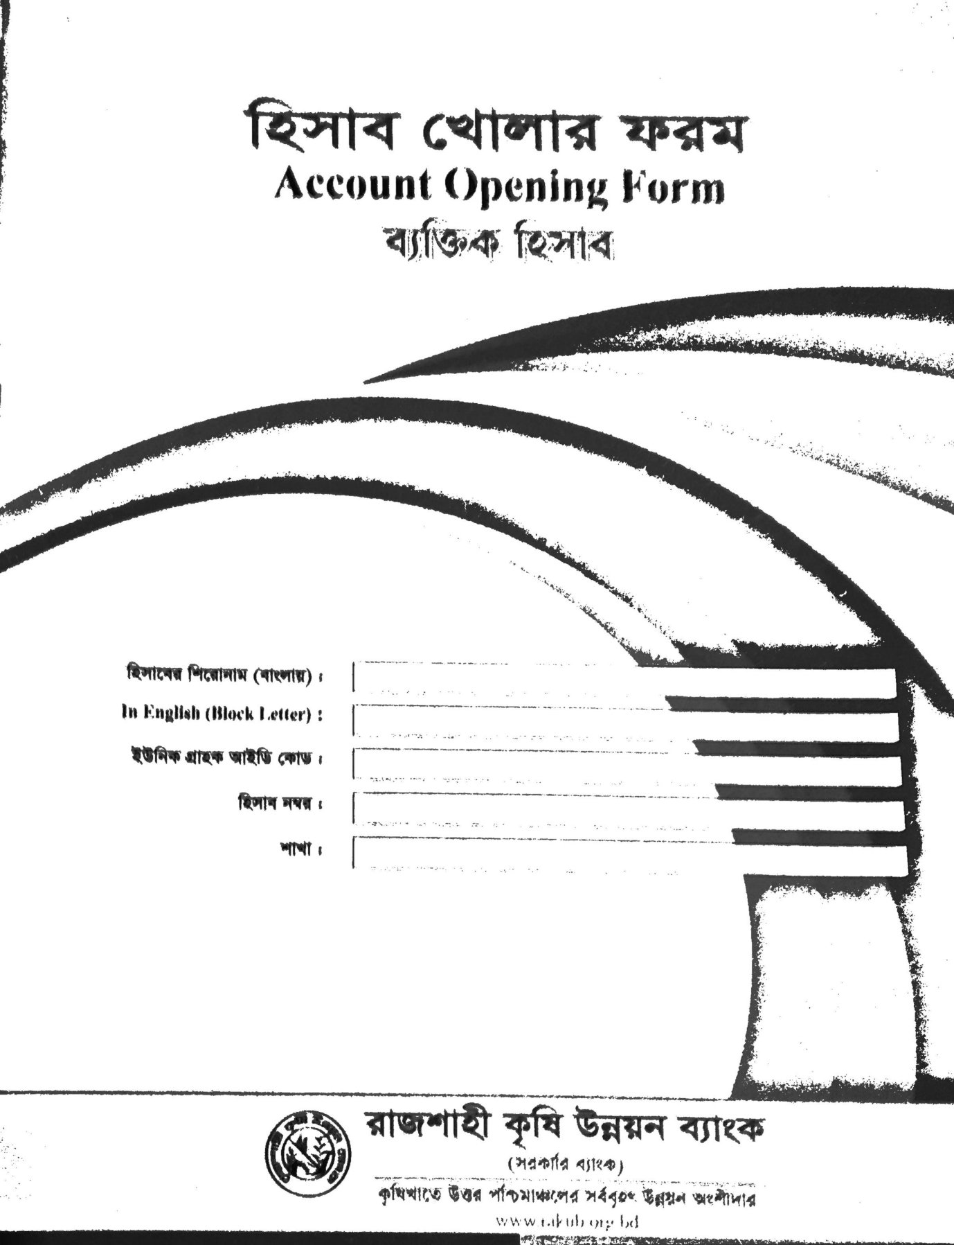

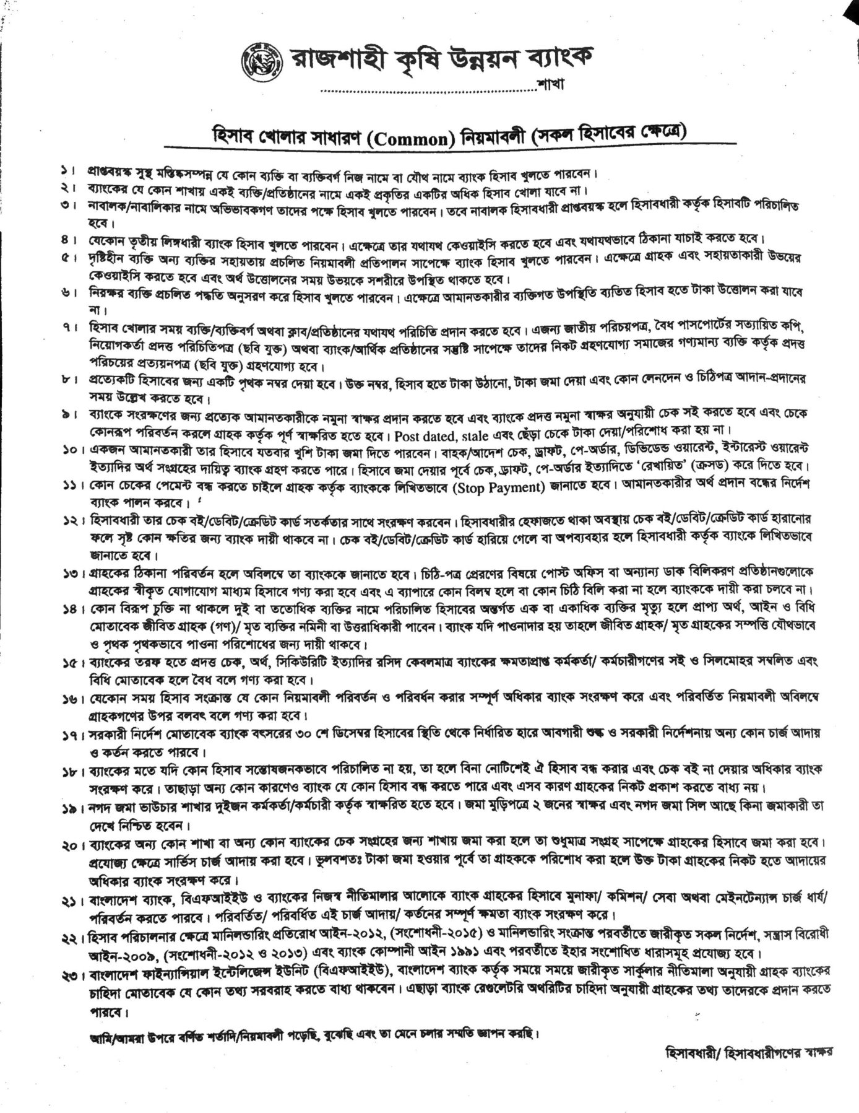

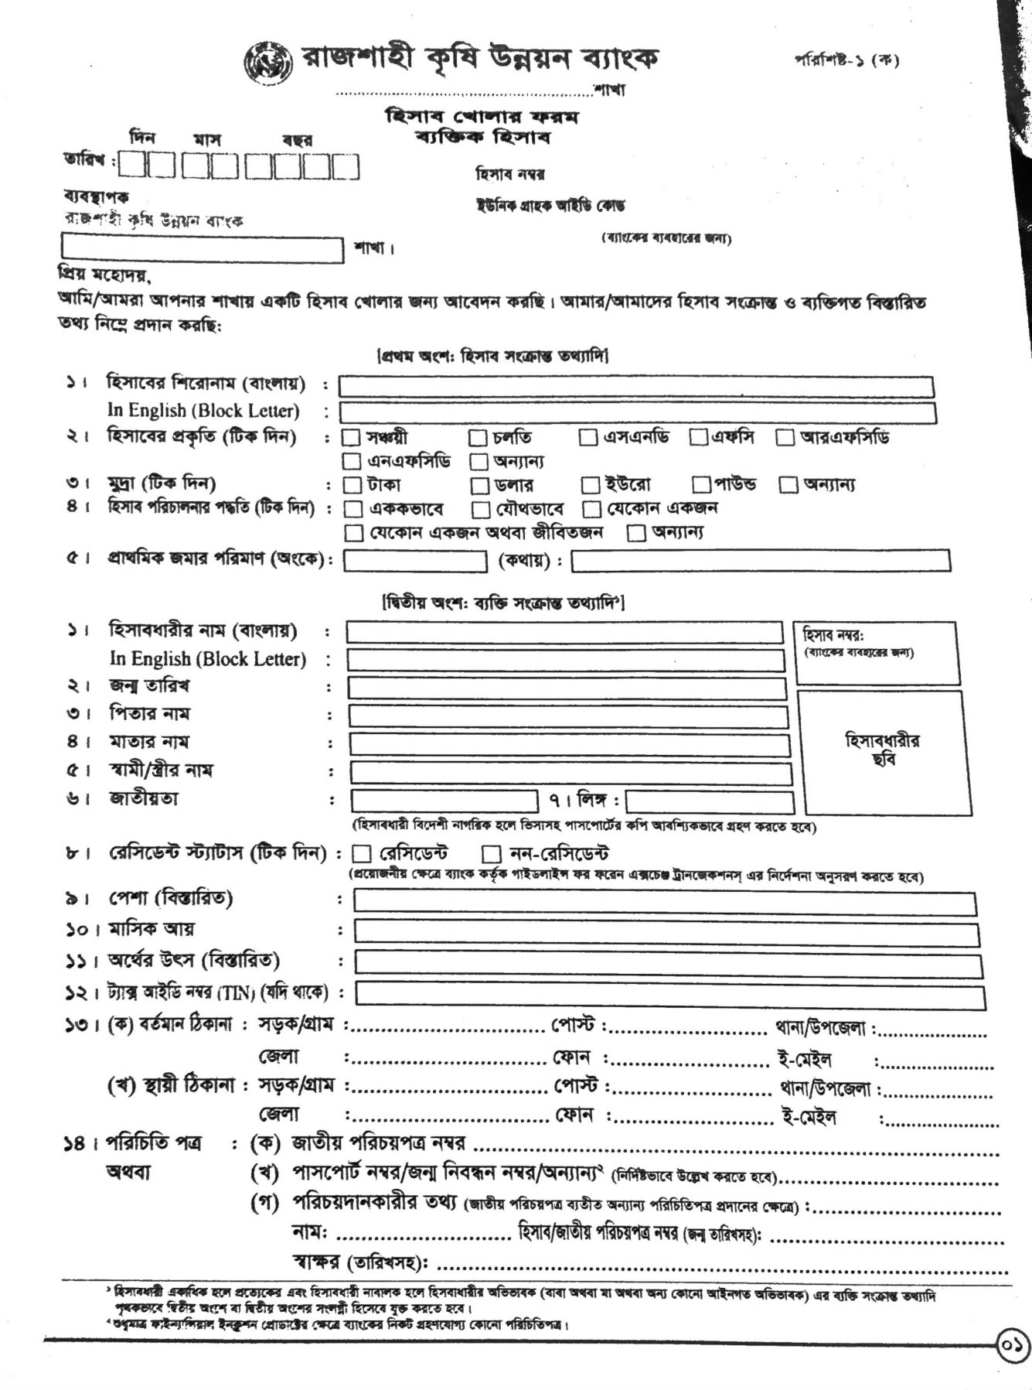

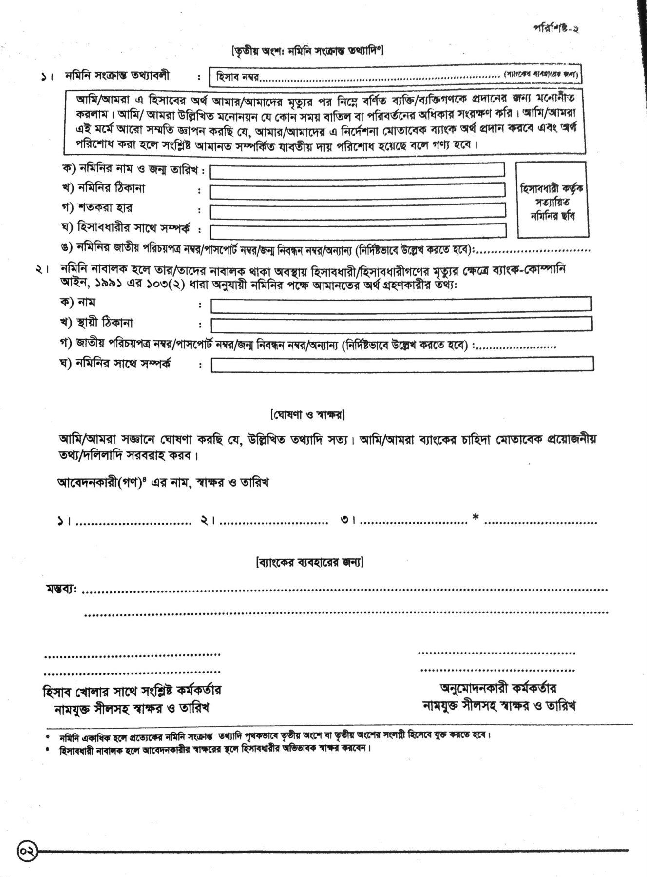

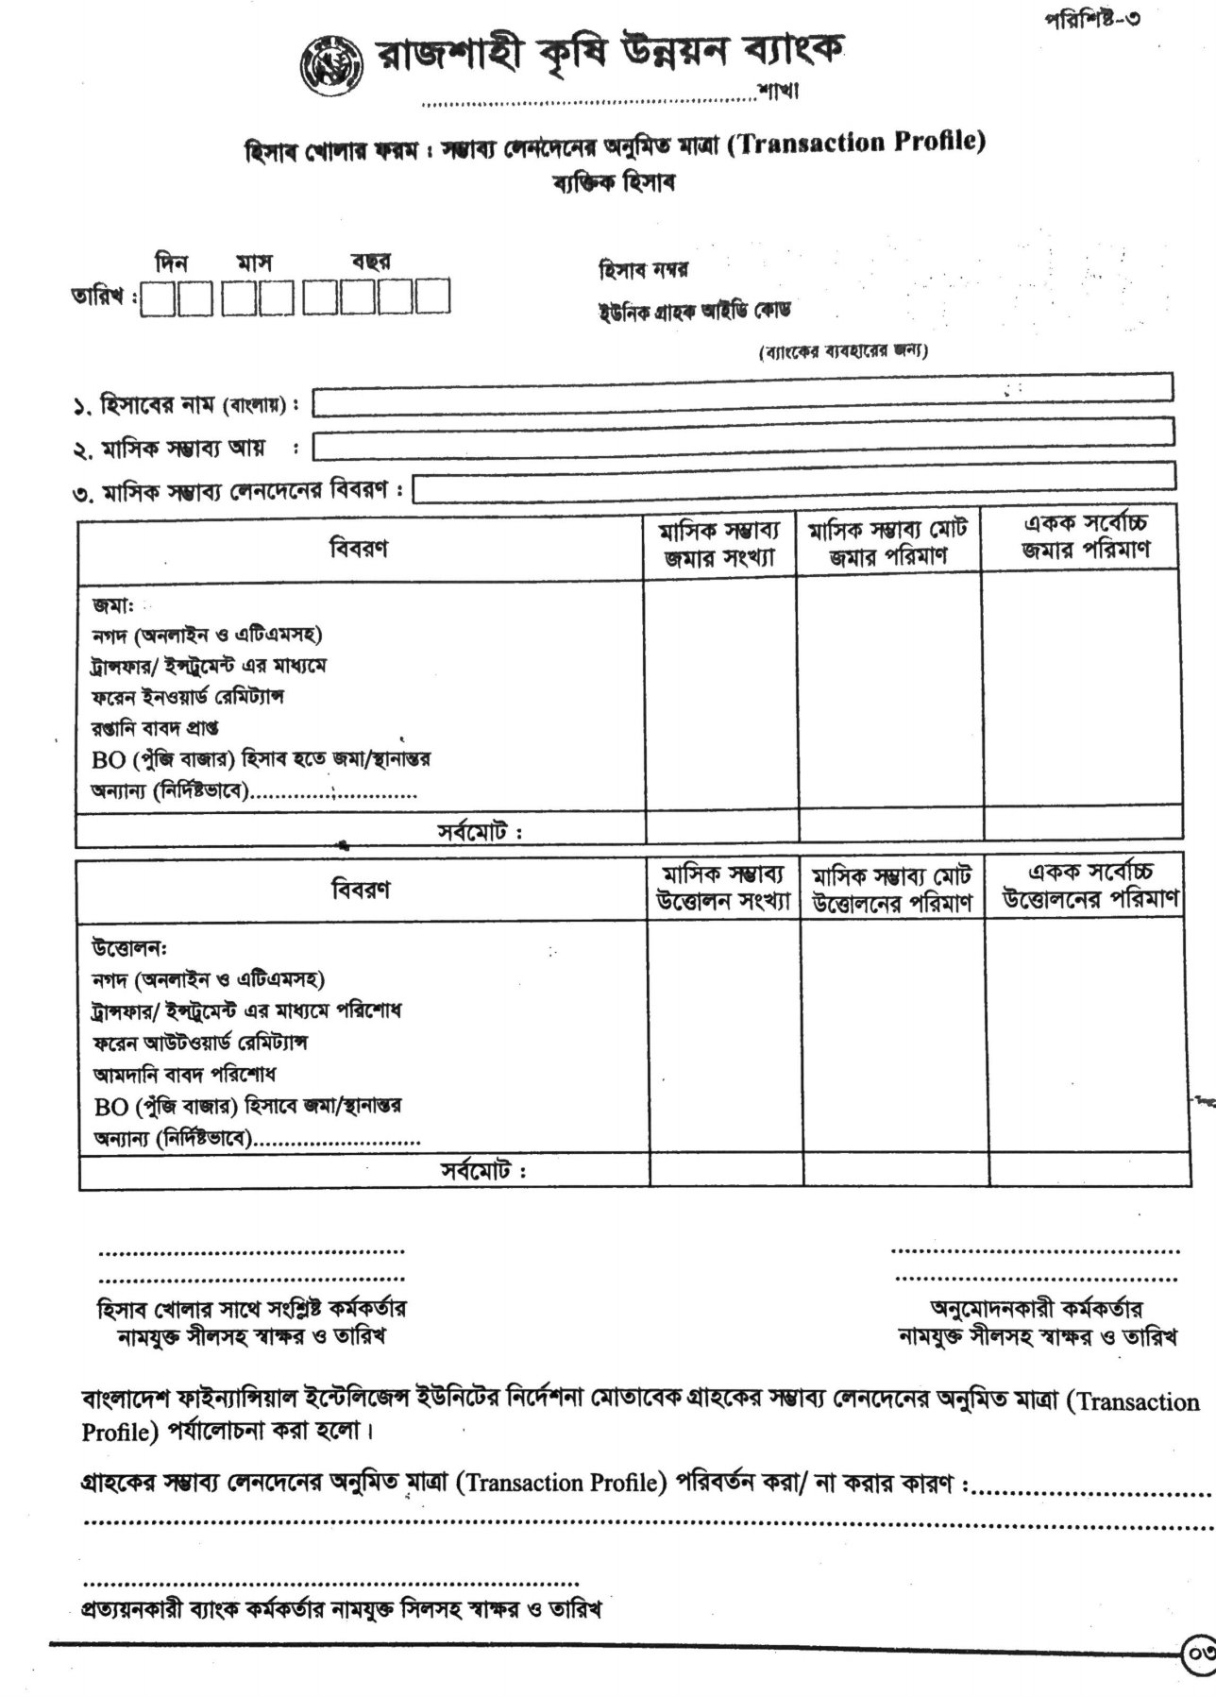

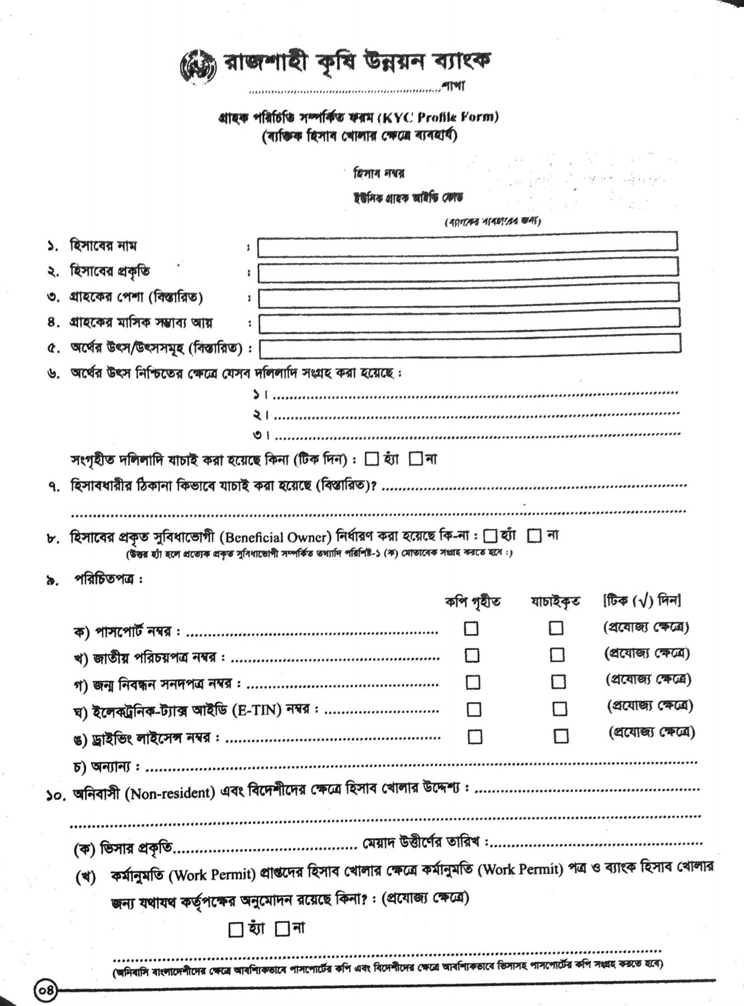

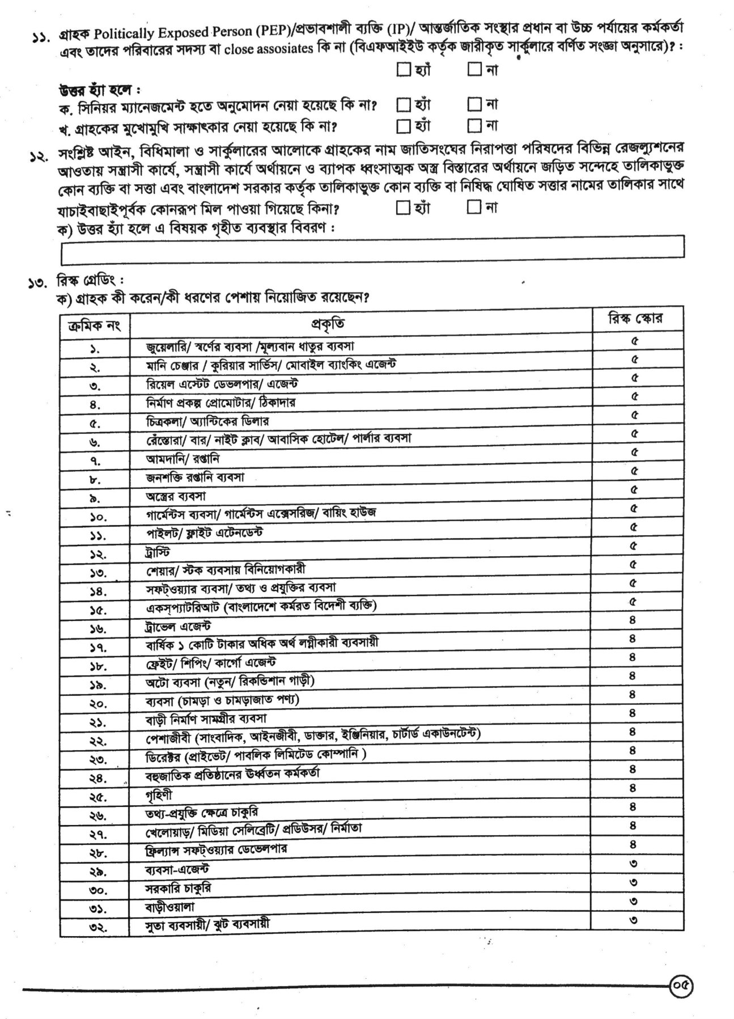

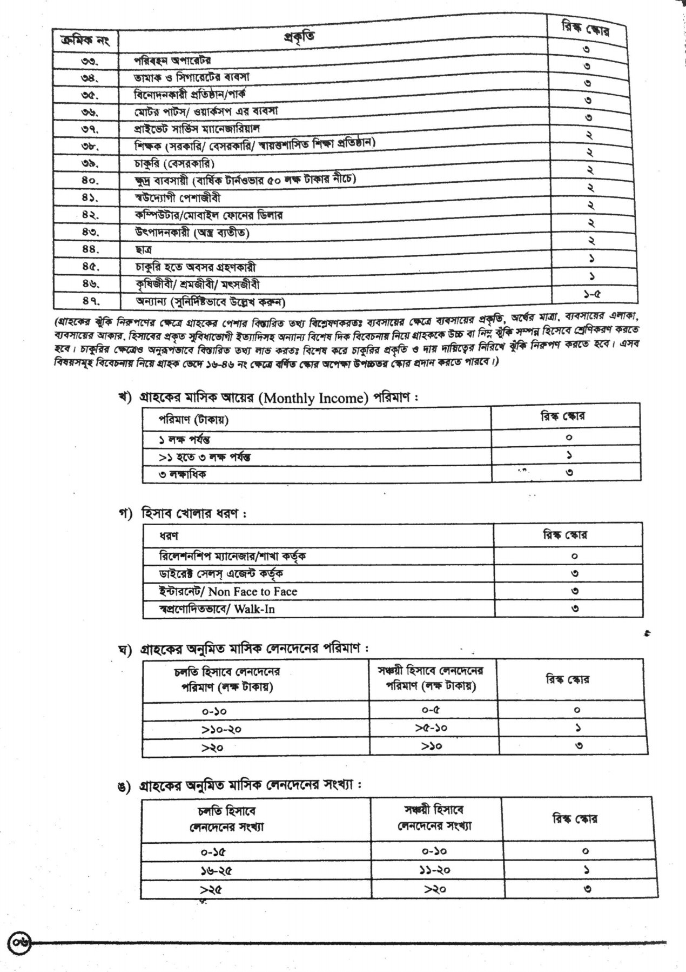

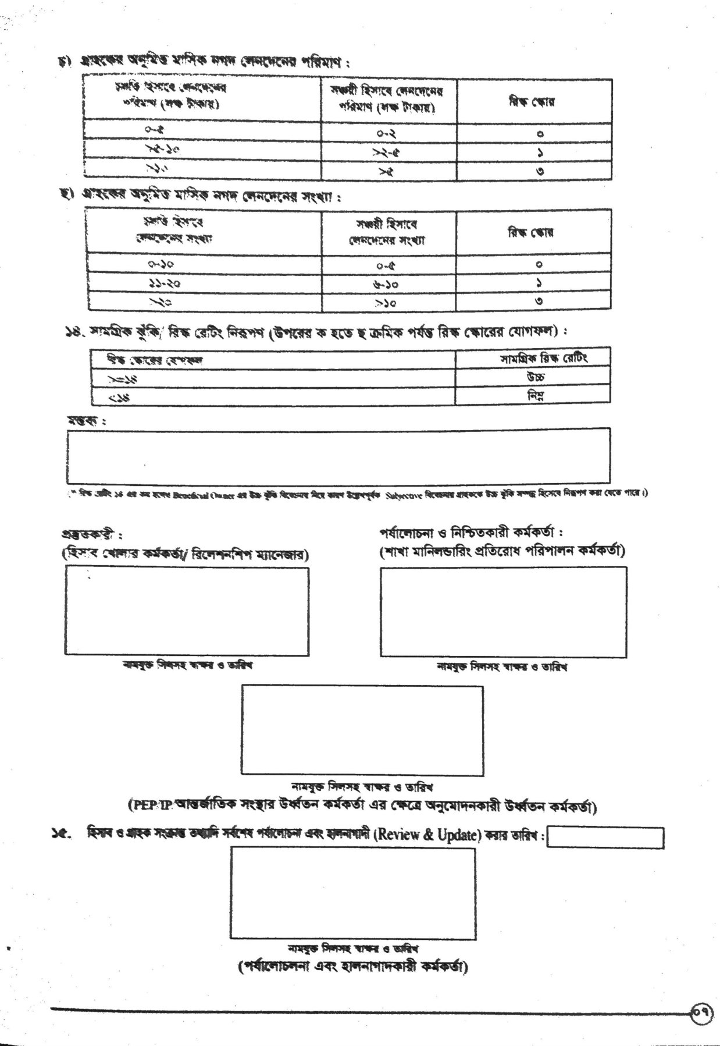

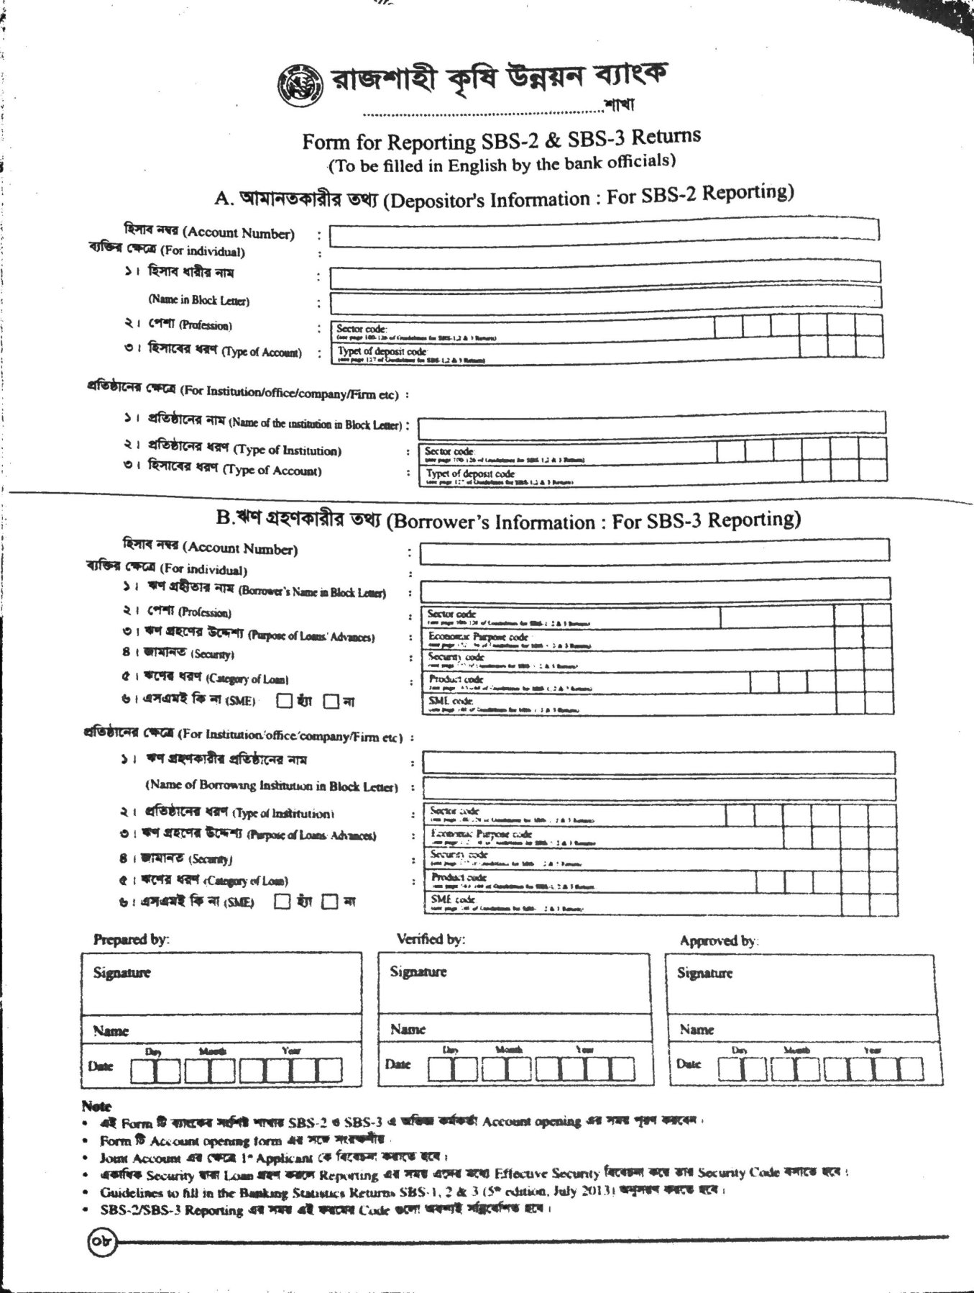

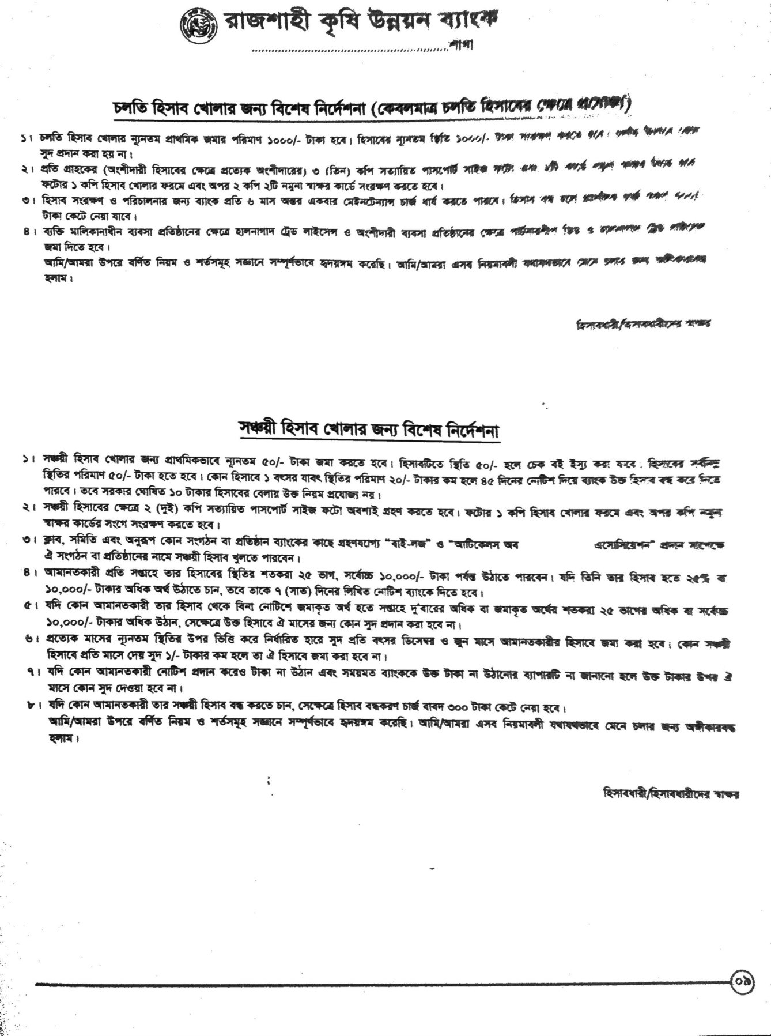

**5.2.2. Term Loan Application form by pledging assets**

A term loan is usually meant for equipment, real estate, or working capital paid off between one and 25 years. By using the cash from a term loan one generally purchases fixed assets. This form is used to get information from a potential borrower to determine if a loan can be approved. There are three main classifications found in Term Loans: short-term term loan, intermediate term loan, and long-term term loan. The fields of the form are:

1.Loan account requested and loan case no: The requested amount of the client that he wants to get as a loan and the case number is filled by the bank.

2.Amount of application fee with pay slip: Details of application fees, pay slip, signature of the received person, date of the information etc.

3.Information of applicant: Personal information of the client that are needed for a loan.

4.Purpose of applied loan: Client has to describe why he wants to take the loan, for which fields in his business.

5.Details of loan plan: A complete description of the planning with the loan is given here. Proof must also be submitted with this form if necessary.

6.Property details of applicants: The small description of his property. It can be agricultural or non-agricultural land, house, project machinery or others.

7.Proposed property for mortgages: Agricultural land or any other property may be kept for the mortgages.

8.Financial Depts/Loan: If the client has any previous record of loan in any bank, then he has to fill this.

9.Applicants signature: The client ensures that all the information given above is true and give his signature in front of the witnesses.

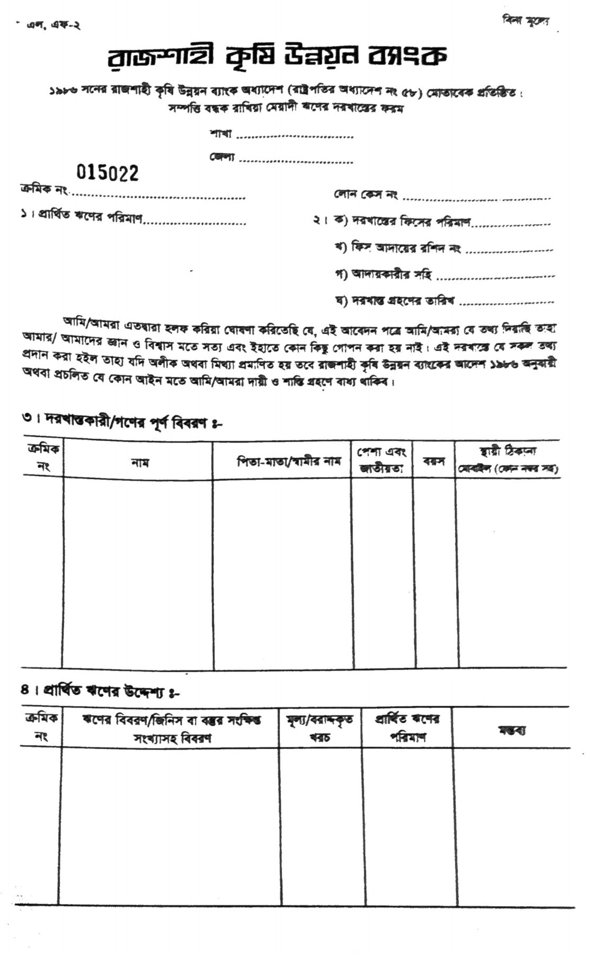

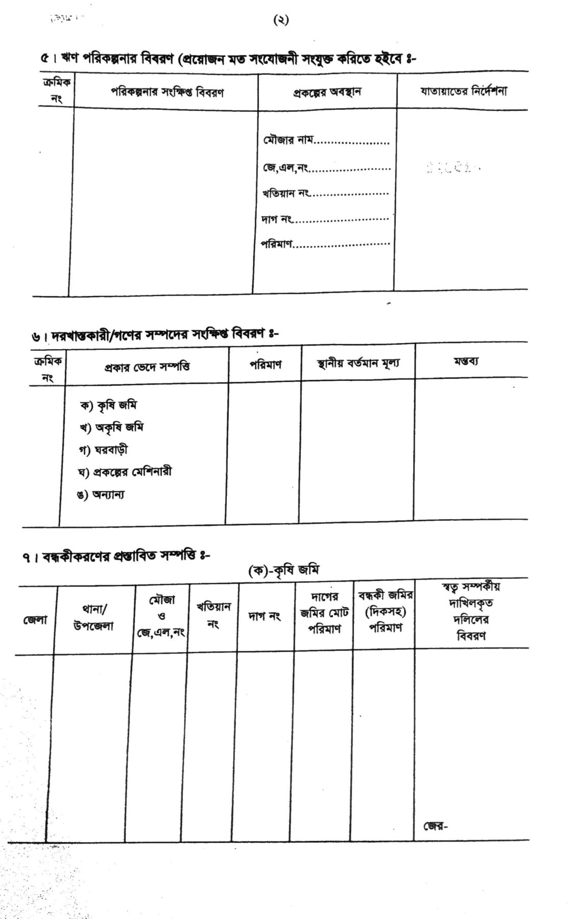

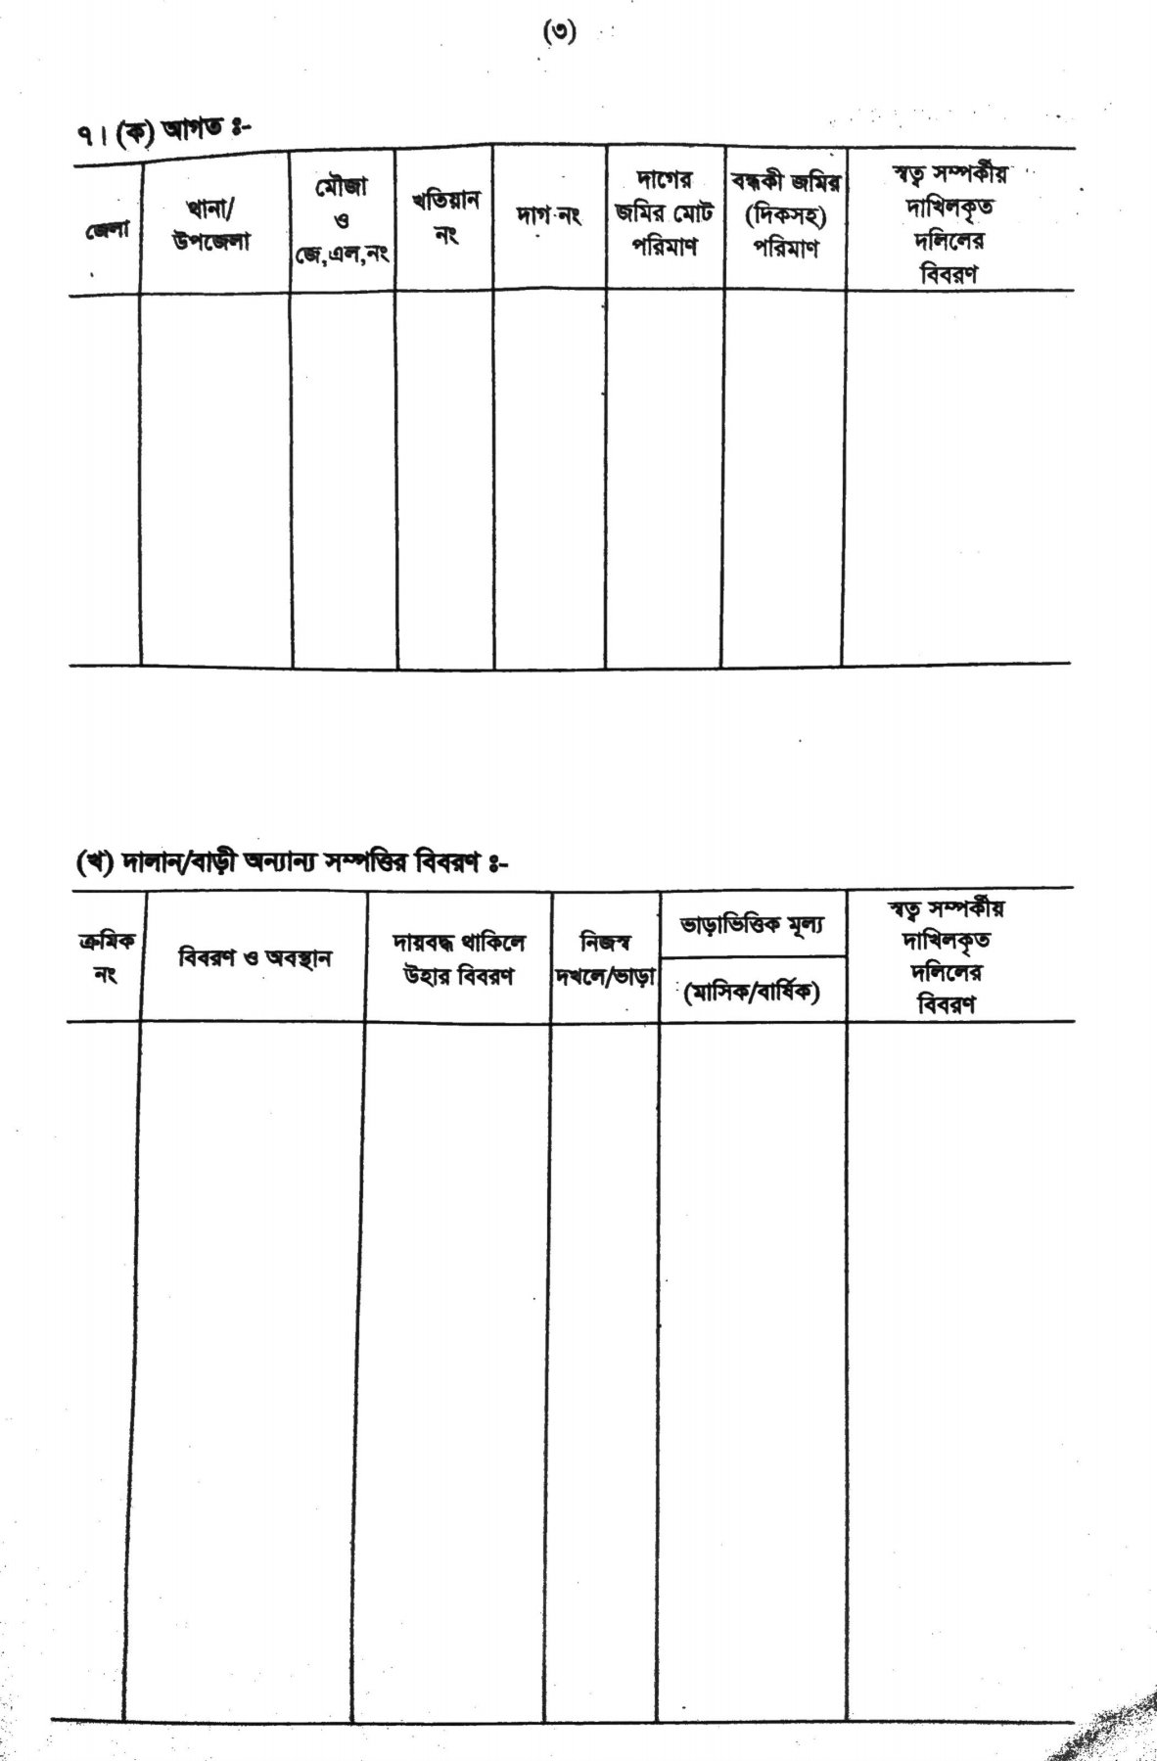

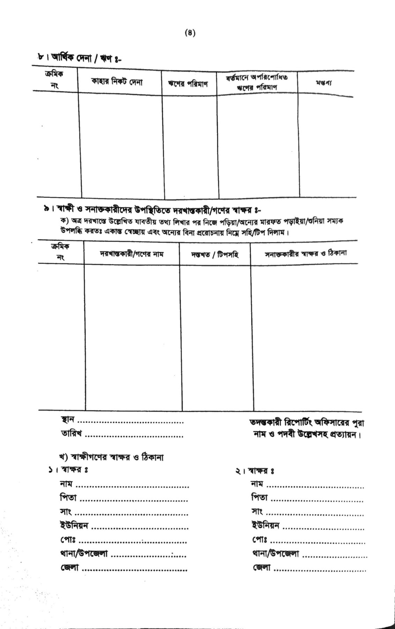

**5.2.3. Working Capital / CC Application Form**

CC or a cash credit is a short-term loan that a company can take from a bank. The company can withdraw money from a bank account without keeping a credit balance. The account is limited to only borrowing up to the borrowing limit. To do this, a form must be submitted. The fields of the form are:

1.Loan case no: The case number is filled by the bank.

2.Date of application received: When the application was taken from the client.

3. Amount of applied loan: The loan that the client wants is submitted here.

4. Loan processing fees: Amount needed for the whole process.

5. Information of applicants: The personal information that are needed to further proceed.

6. Organization management: Name, location of the organization, the manager details etc.

7.Purpose of the loan: How will the client implement the loan. He has to describe it broadly.

8. Collateral offered for the loan: Details of the property he wants to keep as mortgages.

9.Nature of business: What kind of business he wants to do.

10.Information of previous project: If he wants to renew his business, he has to give the previous state and details of the of the business.

11.Production capacity of the project: How much product the business can give as output. What are the purchase and sales price of the products, how much is the benefit etc.

12.Production details of the last 2 years: Previous records of the business and its related products.

13.Current production: What is the present state of the business. Details of the current business strategies.

14.Predictions for next year (production): What he expects from his business in the next year.

15.Current stalk product details: Details of raw materials, the amount of materials and the current price of the product.

16.Raw materials: Description of each raw materials along with items and other details

17.Marketing of products: What is the market situation of his products.

18.Estimated working capital requirement: The client has to represent a list of his needed material price in a year.

19.Details of current loans: : If the client has any previous record of loan in his business, then he has to fill this.

20.Cash flow statement of organization for 1 year: How much money his business will make and how it will spend it in a year. It also shows how well the company is managing its cash to pay back debt and fund operating expenses.

21.Others: Other necessary information or documents that are needed to supply as a proof.

22.Affidavid: The client ensures that the information within the document is true and correct to the best of his knowledge

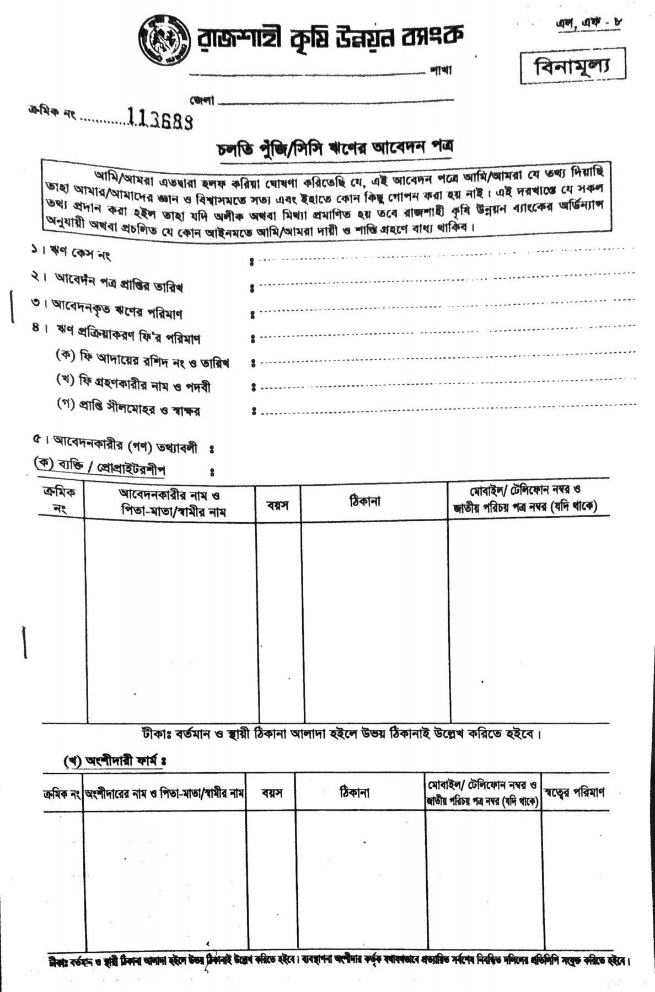

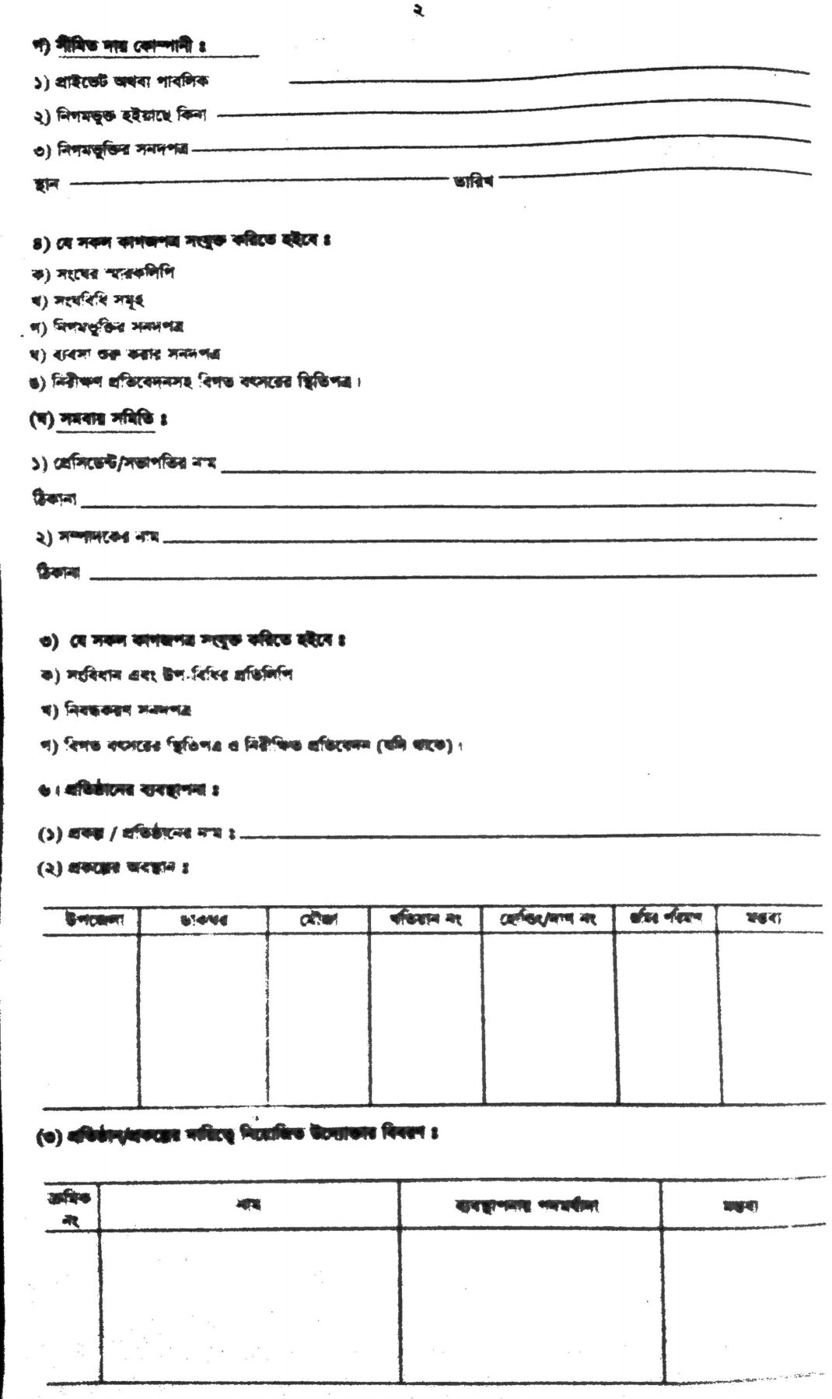

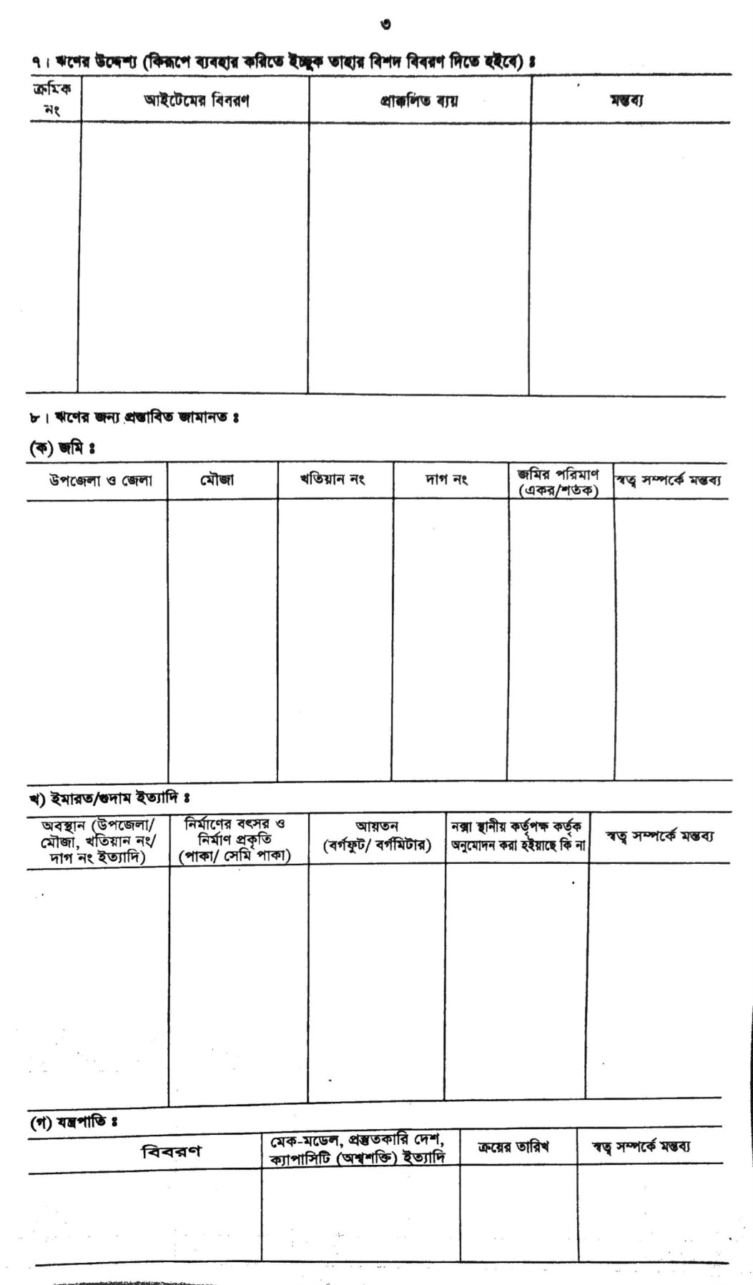

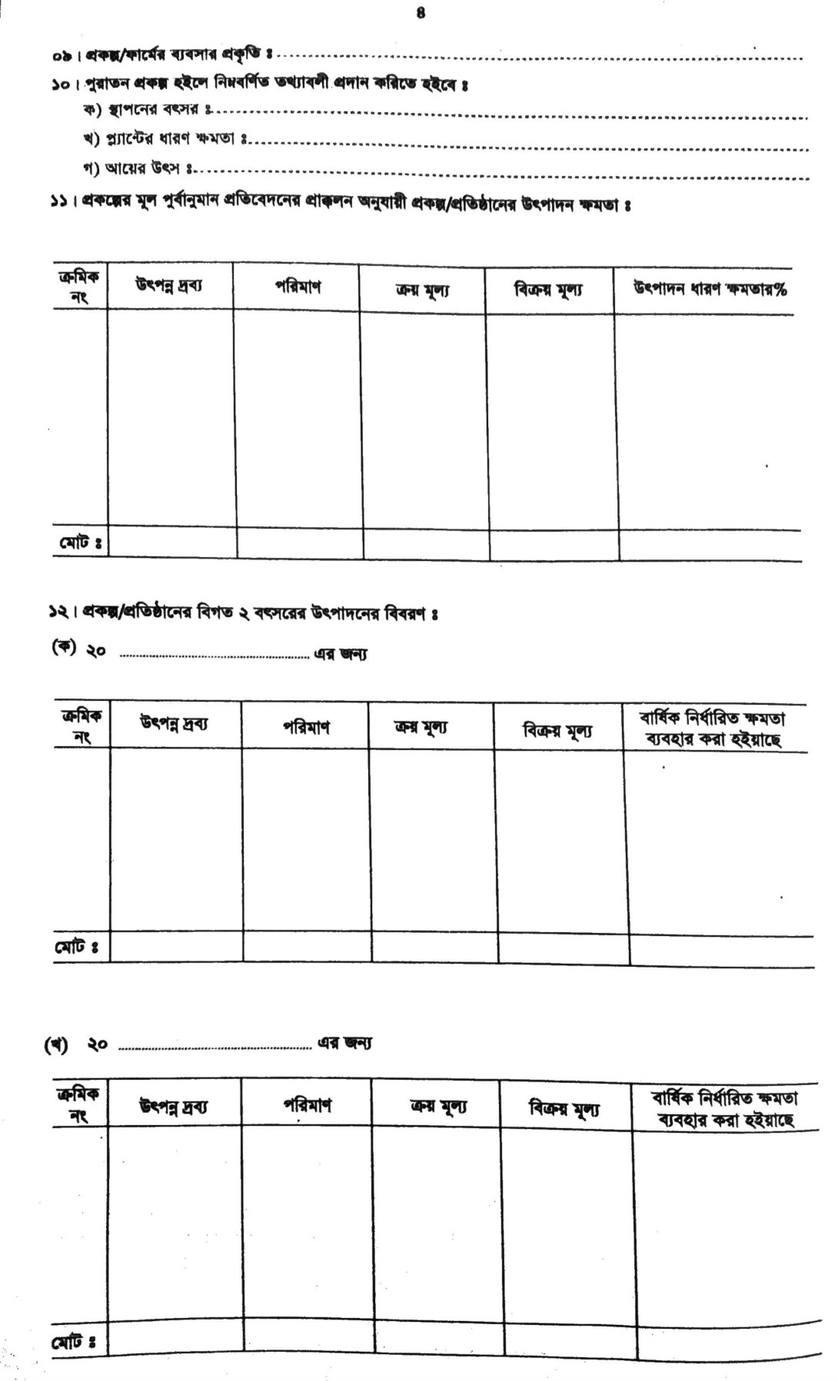

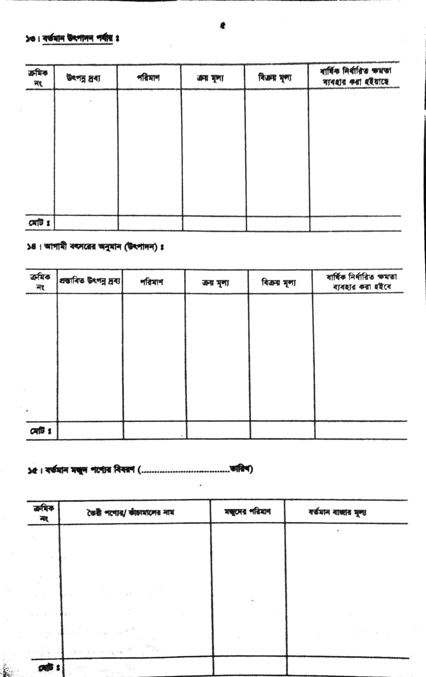

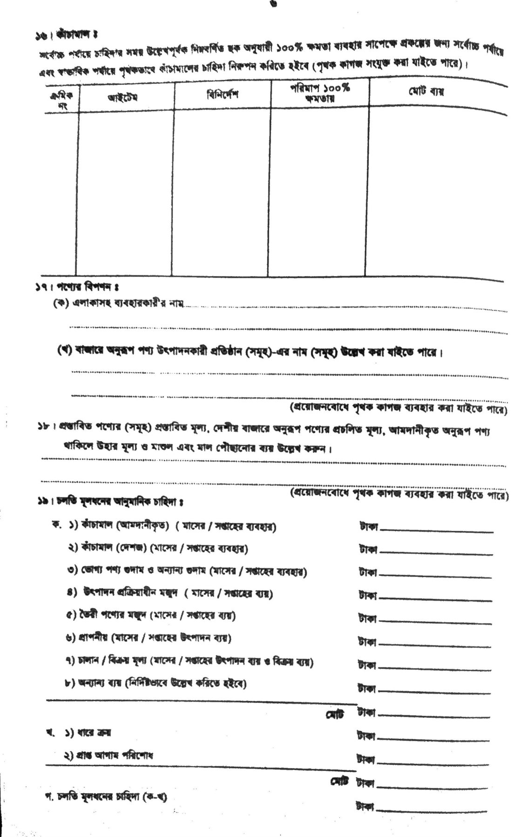

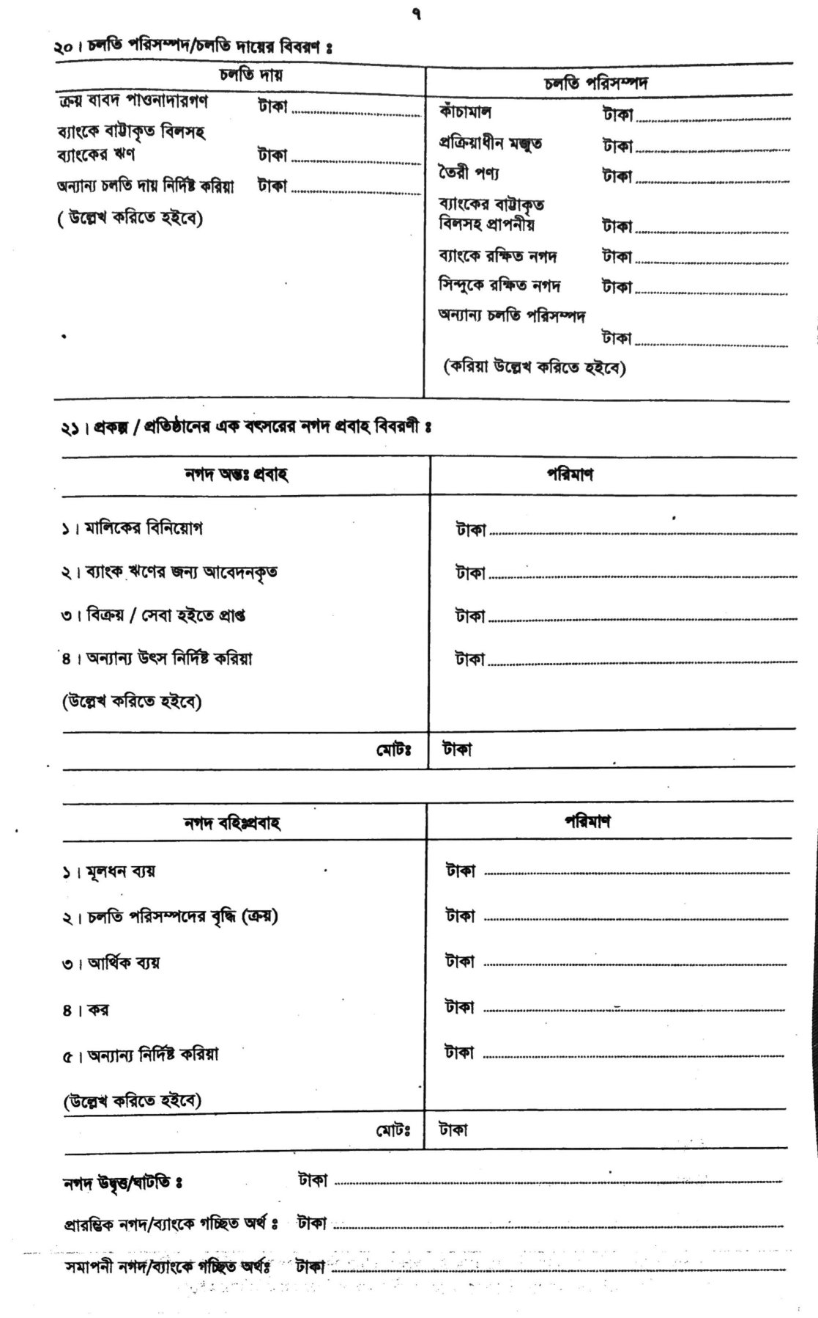



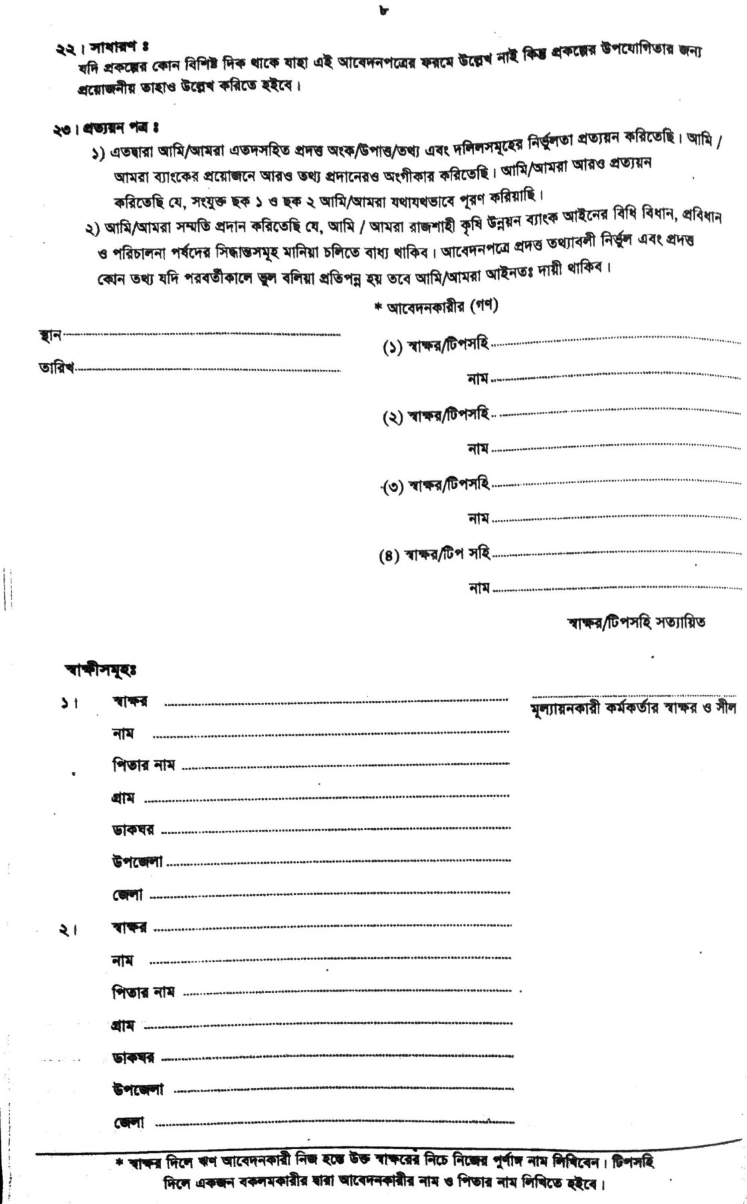

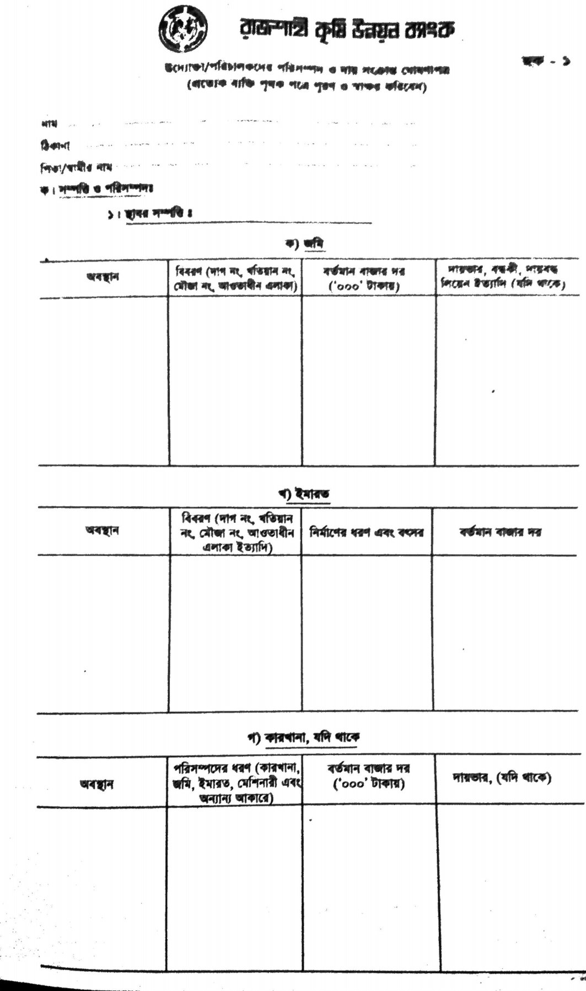

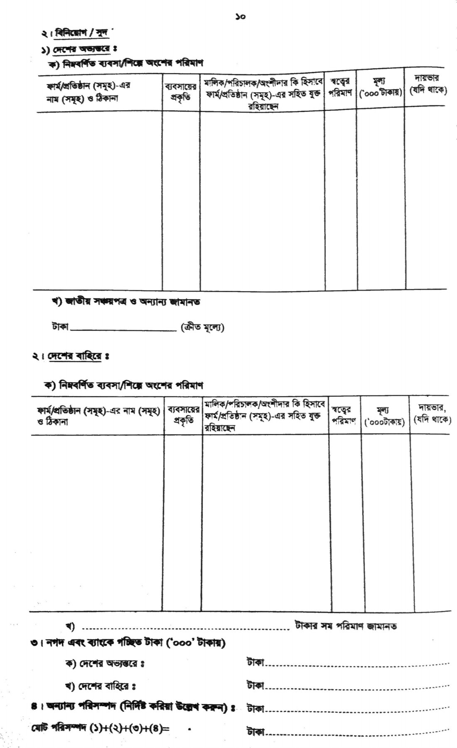

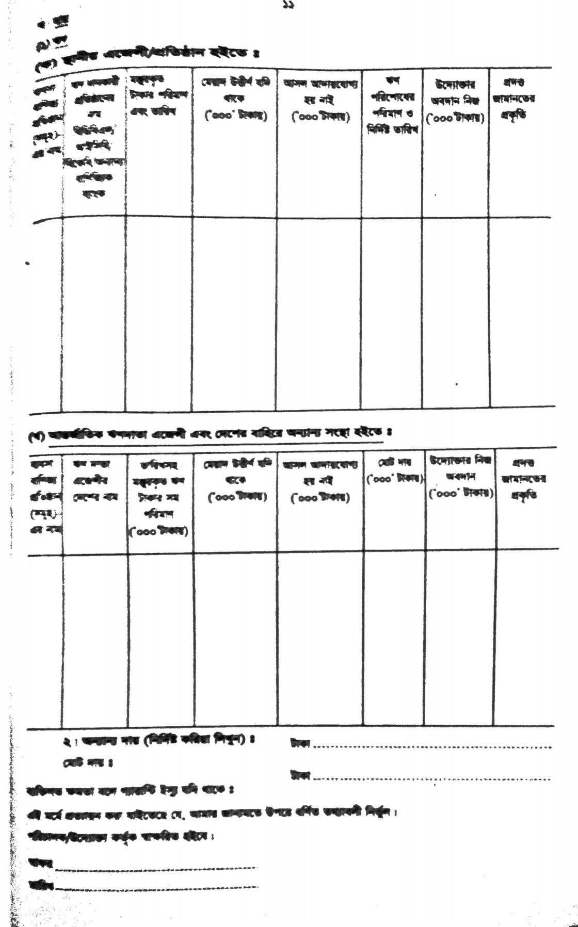

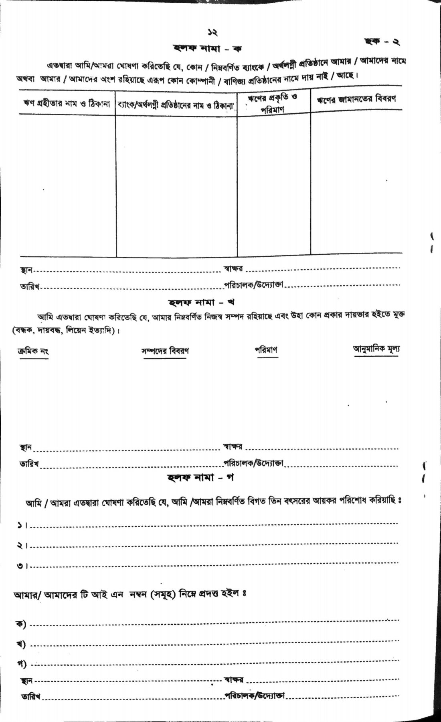

**5.3 Conclusion**

The most important banking services are checking and 3333savings accounts, loan and mortgage services, wealth management, providing Credit and Debit Cards, Overdraft services. In order to perform these services, the bank must need to process information correctly. Thus, forms work as an essential medium. As the bank has to maintain a huge amount of data, the form must be effective and redundancy free. Thus, the forms are designed in a user-friendly way.

In order to secure the information gained from the forms, database system is used. It helps to add, delete, update or monitor the information. Now-a-days, digital forms are used for interfacing with the central database. But still the bank needs some hardcopy of the document as a backup. So, the importance of the form cannot be ignored.